Activity 3.3: Adding an internal hyperlink
Save 'lesson3_page2.html' to your 'Designing websites 3' folder.
- Edit 'lesson3_index.html' to add a hyperlink to 'lesson3_page2.html' and save the file. When you open the web page in a browser, it should look something like this:
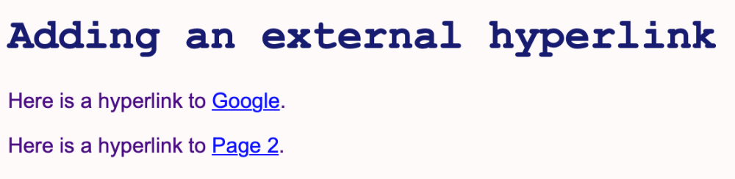
As well as editing 'lesson1_style.css' you will need to edit the text in 'lesson1_index.html.
Take a screenshot of your HTML code and insert it in here:

- Edit 'lesson3_page2.html' to add a hyperlink to 'lesson3_index.html' and save the file. When you open the web page in a browser, it should look something like this:


Take a screenshot of the web page and insert it here:

- Open 'lesson3_index.html' in a browser and practise moving between the pages by clicking on the hyperlinks.

